BCSE410L – Cyber Security Project

AI-Based Penetration Testing Assistant

23BCE0878 | Guru Charan Sivakumar
23BCE2216 | Garvit Kohli
23BCE2221 | Aniket Agrawal

Under the Supervision of

Dr Anto S
School of Computer Science and Engineering (SCOPE)

B.Tech.
in
Computer Science and Engineering

School of Computer Science and Engineering



October 2026

ABSTRACT
The rapid expansion of connected systems and the increasing sophistication of cyber threats have made continuous vulnerability assessment essential for organizations. Conventional penetration-testing and vulnerability-scanning tools can identify exposed services, insecure configurations and known weaknesses, but their outputs are often fragmented, and their severity ratings do not always represent operational risk. This project develops an AI-based adaptive penetration-testing assistant that combines authorized assessment workflows with machine-learning-supported risk prioritization. The system registers explicitly approved targets, orchestrates controlled scans, normalizes findings and enriches them with National Vulnerability Database and CISA Known Exploited Vulnerabilities information. A hybrid rule-based and Random Forest model then ranks findings according to technical severity, exploit evidence, exposure and asset context, while SHAP explanations show the factors contributing to each priority score.
The prototype is implemented using a React dashboard, FastAPI services, PostgreSQL, Celery and Redis, with MLflow for experiment tracking and Prometheus and Grafana for operational monitoring. Trivy is integrated for container and dependency assessment, and the architecture provides adapters for Nmap, Nuclei and passive ZAP analysis. In the demonstrated Docker environment, eight persistent services were deployed and a Trivy report containing 37 dependency vulnerabilities was imported into the common assessment pipeline. The current Random Forest evaluation recorded 0.750 accuracy and 0.667 macro F1; however, the four-sample test set is treated only as preliminary evidence. The resulting system demonstrates how AI and machine learning can support explainable prioritization, reproducible experiments and auditable security assessment without allowing the model to authorize or execute unrestricted attacks. Future work will expand the labeled dataset, calibrate model probabilities and validate the system across larger controlled laboratory networks.

Keywords - adaptive penetration testing, vulnerability prioritization, Random Forest, SHAP, Trivy, NVD, CISA KEV, explainable AI

TABLE OF CONTENTS

Sl.No | Contents | Page No.
 | ABSTRACT | ii
1. | INTRODUCTION | 1
 | 1.1 Background | 1
 | 1.2 Motivations | 1
 | 1.3 Scope of the Project | 1
2. | PROJECT DESCRIPTION AND GOALS | 2
 | 2.1 Literature Review | 2
 | 2.2 Research Gap | 3
 | 2.3 Problem Statement | 3
 | 2.4 Objectives | 3
 | 2.5 Project Plan | 4
3. | TECHNICAL SPECIFICATION | 5
 | 3.1 Requirements | 5
 | 3.1.1 Functional | 5
 | 3.1.2 Non-Functional | 5
 | 3.2 Feasibility Study | 5
 | 3.2.1 Technical Feasibility | 5
 | 3.2.2 Economic Feasibility | 5
 | 3.2.2 Social Feasibility | 6
 | 3.3 System Specification | 6
 | 3.3.1 Hardware Specification | 6
 | 3.3.2 Software Specification | 6
4. | DESIGN APPROACH AND DETAILS | 7
 | 4.1 System Architecture ( Not Flow diagram/flow chart) | 7
 | 4.2 Design | 8
 | 4.2.1 Algorithm1 | 8
 | 4.2.2 Algorithm 2 | 8
5. | EXPERMENTAL SETUP AND OUTPUT | 10
 | 5.1 Experimental Setup | 10
 | 5.2 Output of the Proposed System | 10
6. | RESULT ANALYSIS | 12
 | 6.1 Comparison with existing Systems | 13
7. | CONCLUSION AND FUTURE WORKS | 14
8. | REFERENCES | 15

1. INTRODUCTION

1.1 Background
Organizations use vulnerability scanners and penetration-testing tools to identify exposed services, insecure configurations and known software weaknesses. These tools usually produce separate outputs and assign severity using their own conventions. Analysts must then determine which findings affect important assets, which require immediate attention and which can be deferred. The Common Vulnerability Scoring System provides a standardized measure of technical severity [11], while the National Vulnerability Database and the CISA Known Exploited Vulnerabilities Catalog supply vulnerability and exploitation context [12], [13]. Recent reviews of AI-assisted penetration testing show that reinforcement learning dominates much of the research, but real-world adoption, environment fidelity and support across all testing phases remain limited [2], [5].
The proposed system integrates the assessment lifecycle in one application. It registers targets, records approval windows, queues-controlled scans, converts tool-specific results into a common schema and combines deterministic risk factors with a supervised model. The system also retains component scores and model confidence so an analyst can inspect how a priority was formed. Live operations remain restricted to authorized laboratory targets, and the default deployment uses mock or non-exploitative assessment paths.

1.2 Motivation
Security teams often receive more findings than they can remediate immediately, while manual penetration testing remains time-intensive and dependent on scarce specialist knowledge. Becker et al. demonstrated that an A3C agent could solve controlled NASim scenarios and generalize to unseen permutations, although the experiments used small, simulated environments [1]. Fernandes et al. compared contemporary autonomous-pentesting environments and found that no single simulator leads in fidelity, MITRE ATT&CK coverage and scalability [2]. LLM-based work also shows promise: Happe and Cito relate LLM effectiveness to pattern recognition and uncertainty handling but emphasize reliability, safety, privacy and accountability concerns [3], while Henke's AutoPentest completed only 15-25 percent of subtasks in three Hack The Box experiments and incurred higher experimental cost than the comparison subscription [4]. These findings motivate a bounded assistant that preserves structured state, requires authorization and explains prioritization instead of attempting unrestricted autonomous exploitation.

1.3 Scope of the Project
The project covers target registration, role-based access, authorization windows, mock assessment, scanner normalization, NVD and KEV enrichment, hybrid prioritization, SHAP explanations, queued processing, monitoring, audit logs and reporting. Trivy supports container and dependency assessment, while Nmap, Nuclei and passive ZAP adapters support controlled asset, template and web observations. The project excludes exploit execution, credential attacks, persistence, destructive payloads and unsupervised public-target scanning.

2. PROJECT DESCRIPTION AND GOALS
2.1 Literature Review
Study | Main Contribution | Relevance to the project
[1] Becker et al. 2024 | Evaluated Q-learning, DQN and A3C in an extended NASim environment across exploitation, post-exploitation and wiretapping scenarios. A3C solved all scenarios and showed limited generalization, but the state and action spaces were small. | Supports controlled adaptive sequencing and highlights the need to test generalization rather than only training success.
[2] Fernandes et al. 2026 | Compared autonomous-penetration testing and reinforcement-learning environments by fidelity, MITRE ATT&CK coverage, emulation support, reward design and scalability. No environment was strongest across every criterion. | Justifies a modular architecture and cautions against treating simulator results as direct evidence of real-network effectiveness.
[3] Happe and Cito 2025 | Reviewed academic and industrial use of LLMs across penetration-testing activities. The authors attribute their usefulness to pattern matching and uncertainty handling while identifying reliability, safety, privacy, cost and accountability risks. | Supports an explainable assistant with human oversight instead of an unrestricted autonomous agent.
[4] Henke 2025 | Implemented AutoPentest using GPT-4o and LangChain and evaluated it on three Hack The Box machines. AutoPentest slightly outperformed direct ChatGPT use, but both completed only 15-25 percent of subtasks and the agent experiments cost USD 96.20. | Provides empirical evidence that LLM orchestration remains incomplete and must be evaluated for effectiveness and operational cost.
[5] Curtis and Eisty 2025 | Systematically reviewed 58 peer-reviewed studies. Reinforcement learning accounted for 77 percent of reviewed work, with most research focused on discovery and exploitation and limited coverage of reconnaissance and post-exploitation. | Defines the broader research gap and supports focusing this prototype on auditable workflow integration and prioritization.
[6] Zhan et.al. 2026 | Proposed L-ARLPT, which combines an LLM-based knowledge layer with a Deep Q-Network and Prioritized Experience Replay. The LLM reduces the large action space, while reinforcement learning optimizes long-term penetration-testing decisions. | Supports combining AI reasoning with adaptive decision-making while demonstrating the importance of restricting automated actions to controlled environments.
[7] Liu et al. 2026 | Systematically reviewed reinforcement-learning approaches to autonomous penetration testing. The study categorized existing work into attack-path planning and complete testing frameworks and identified limitations involving realism, scalability and generalization. | Supports the project’s controlled and modular architecture and cautions against treating results from simulated environments as direct evidence of real-network effectiveness.
[8] Wang et al. 2025 | Introduced the Planner–Executor–Perceptor architecture and developed CHECKMATE, which combines LLM agents with dynamically updated classical planning. It improved benchmark success rates while reducing execution time and cost. | Supports separating planning, scanner execution and result interpretation into controlled modules instead of allowing an LLM to execute unrestricted actions.
[9] Zhou et al. 2025 | Proposed the GAP framework using a real-to-simulation-to-real workflow, LLM-assisted domain randomization and meta-reinforcement learning. It demonstrated zero-shot transfer to similar environments and faster adaptation to unfamiliar environments. | Highlights the generalization problem in AI-based penetration testing and supports evaluating the proposed system across multiple controlled network configurations.
[10]Das 2026 | Presented EVPD, an explainable vulnerability-prioritization framework trained using NVD, MITRE, EPSS, CVSS and CISA KEV data. A stacked ensemble combining Random Forest, EPSS and CVSS outperformed traditional baselines, while SHAP explained individual predictions. | Directly supports the project’s use of Random Forest, NVD, CISA KEV and SHAP for contextual, explainable vulnerability prioritization.

First, reinforcement learning can learn attack sequences in simulated networks, but generalization depends on training coverage and controlled state and action spaces [1]. Second, current autonomous-penetration testing environments trade realism and attack coverage against scalability, so laboratory success cannot be assumed to transfer directly to operational networks [2]. Third, LLMs can support planning, tool selection and multi-step interaction, but their reliability, cost, safety and accountability remain material constraints [3], [4]. Fourth, systematic-review evidence shows that AI-assisted penetration testing is still concentrated in reinforcement learning and in discovery and exploitation activities, with less mature coverage of reconnaissance and post-exploitation [5]. The proposed project therefore uses AI for bounded prioritization and explanation while keeping authorization, execution policy and auditability under deterministic application control.

2.2 Research Gap
Existing research often treats automated attack planning, vulnerability prediction and scanner orchestration as separate problems. LLM-based systems can plan actions but may lose context or hallucinate unsafe steps. Exploit-prediction models rank vulnerabilities but may not preserve the evidence, authorization state and operational history needed for an assessment. Commercial vulnerability managers integrate tools but provide limited transparency into proprietary prioritization. A gap therefore remains for a small, reproducible academic platform that joins authorization, multi-tool normalization, contextual risk scoring, local explanations, auditable execution and report generation while keeping exploitation outside the default workflow.

2.3 Problem Statement

Raw network, web and dependency scanners produce heterogeneous findings that are difficult to compare and prioritize. Static severity can overstate some findings and understate vulnerabilities that are exposed or known to be exploited. The project must therefore provide an authorized assessment workflow that normalizes scanner evidence, combines severity and contextual signals, ranks findings consistently, explains each priority and generates usable remediation reports without automatically executing exploits.

2.4 Objectives

- Implement target registration, approval windows and role-based controls so every assessment is tied to an explicit authorization record.
- Normalize findings from mock, Nmap, Nuclei, passive ZAP and Trivy inputs into one vulnerability schema during the Project I implementation period.
- Combine rule-based risk and Random Forest output using a documented 40:60 weighting and expose both component scores, confidence and final priority.
- Generate a local SHAP explanation for trained-model decisions and retain a safe fallback when model artifacts are unavailable.
- Queue assessments through Celery and Redis, store data in PostgreSQL and expose operational metrics through Prometheus and Grafana.
- Generate PDF, CSV and JSON reports and demonstrate a complete Docker deployment with imported findings and auditable outputs.
- Evaluate model accuracy and macro F1, record limitations and define a larger-data validation plan before making deployment claims.

2.5 Project Plan
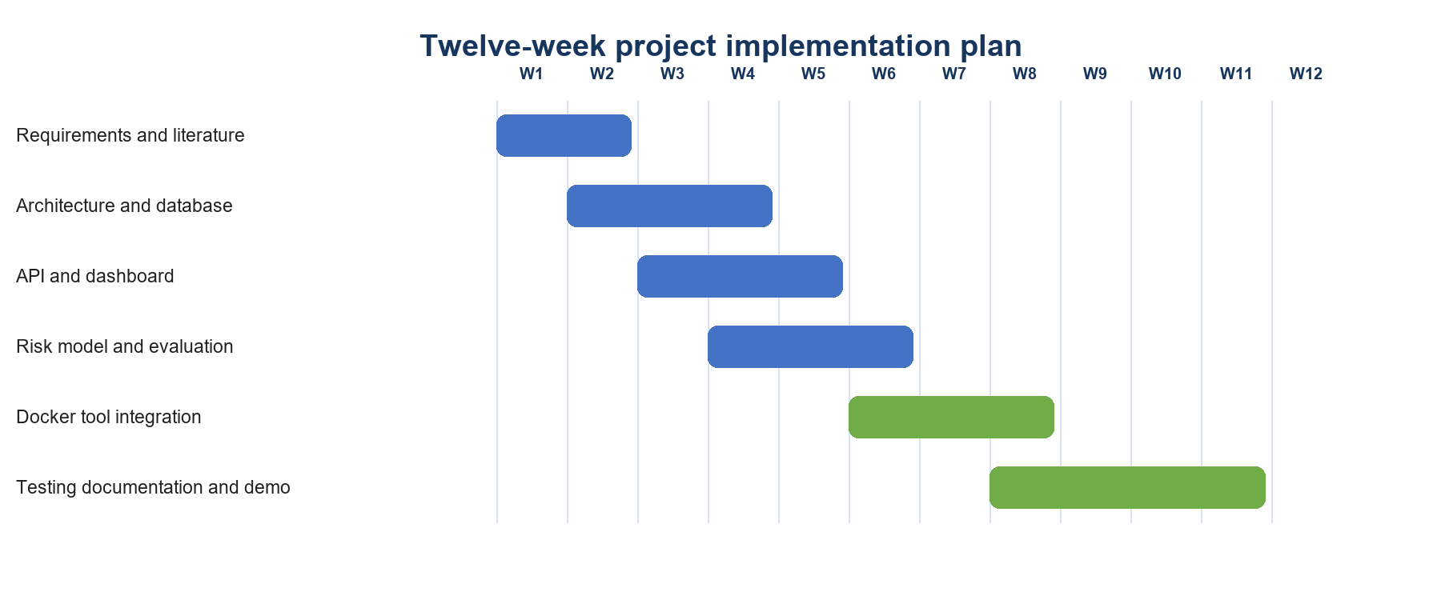
Fig. 1. Gantt chart
3. TECHNICAL SPECIFICATION
3.1 Requirements
3.1.1 Functional
- Authenticate users and enforce administrator, analyst and viewer permissions.
- Create targets and store the target type, host, description and authorization period.
- Reject scans when authorization is missing, expired or outside its approved window.
- Run mock assessments by default and allow controlled adapters only when live mode is explicitly enabled.
- Normalize assets and vulnerabilities, enrich CVEs from NVD and CISA KEV, and calculate hybrid risk.
- Queue long-running jobs, record status transitions and support cancellation state.
- Display dashboard summaries, findings, scores and recommendations.
- Export PDF, CSV and JSON evidence and maintain an administrator-readable audit log.
- Import Trivy JSON for an authorized target and export completed findings in a DefectDojo-oriented structure.

3.1.2 Non-Functional
- Safety: live scanning is disabled by default, public targets are rejected by policy, and no exploit execution is implemented.
- Reliability: PostgreSQL and Redis health checks prevent the backend and worker from starting before dependencies are ready.
- Traceability: each scan records its user, target, tool, mode, timestamps, status and failure message.
- Performance: long jobs execute outside the API process, and request latency is measured through Prometheus histograms.
- Maintainability: scanner parsing, enrichment, machine learning and task execution are separated into modules.
- Reproducibility: Docker Compose defines the service topology and MLflow records model parameters, metrics and artifacts.

3.2 Feasibility Study
3.2.1 Technical Feasibility
The prototype uses open-source components with available Python and container support. FastAPI, SQLAlchemy, PostgreSQL, Redis and Celery run as Docker services. The Random Forest model uses scikit-learn, and SHAP supports the selected tree model. Trivy, Prometheus and Grafana have maintained container images. The demonstrated deployment started all eight persistent services and completed a Trivy scan and import, which establishes technical feasibility for a single-host academic environment.

3.2.2 Economic Feasibility
The software stack does not require paid licenses for academic development. The primary cost is the student workstation, storage for container images and the time required to maintain scanner templates and vulnerability data. A small deployment can run locally; larger assessments would require more memory, storage and controlled network infrastructure. The system therefore has low prototype cost, while production hardening and ongoing threat-data maintenance would create additional operational cost.

3.2.3 Social and Ethical Feasibility
The interface keeps an analyst in control and presents recommendations as evidence for review rather than proof of compromise. Authorization windows, role checks and audit logs discourage casual misuse. Scanner findings can include false positives and must be validated. The project does not infer intent, guilt or user behavior. Live scanning must be limited to systems owned by the operator or covered by written permission.

3.2 System Specification
3.2.1 Hardware Specification

Component | Minimum development configuration | Recommended
Processor | 64-bit dual-core CPU with virtualization | Modern quad-core or higher
Memory | 8 GB RAM | 16 GB RAM for the full Docker stack
Storage | 15 GB free SSD space | 30 GB free SSD space for images and reports
Network | Host-only or isolated laboratory network | Separate authorized virtual lab
Display | 1366 x 768 | 1920 x 1080

3.2.2 Software Specification

Layer | Technology | Role
Operating system | Windows 10 or 11 with WSL 2 | Development host and Docker Desktop
Frontend | React, TypeScript and Vite | Dashboard and operator workflow
Backend | Python 3.12, FastAPI and Uvicorn | REST API and assessment logic
Persistence | PostgreSQL 17 and SQLAlchemy | Targets, findings, scores and audits
Queue | Celery and Redis | Background assessment execution
Machine learning | scikit-learn, SHAP and MLflow | Risk prediction, explanation and experiment tracking
Security tools | Trivy; controlled Nmap, Nuclei and ZAP adapters | Dependency, network and web assessment
Monitoring | Prometheus and Grafana | Request counts, latency and operations dashboard
Deployment | Docker Desktop and Docker Compose | Reproducible multi-service environment

4. DESIGN APPROACH AND DETAILS

4.1 System Architecture
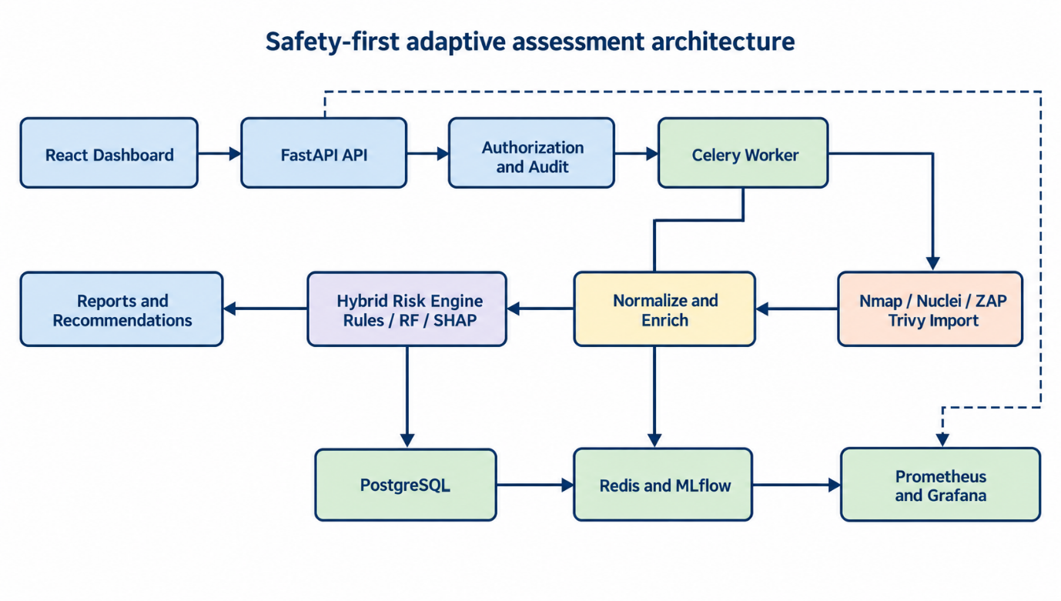
Fig. 2. System Architecture

The dashboard communicates with the FastAPI service over authenticated REST endpoints. The API validates the user role and current target authorization before creating a scan record. When queueing is enabled, Celery sends the job through Redis to a bounded worker. Scanner outputs pass through a normalization layer that creates common asset and vulnerability records. CVE identifiers are enriched from NVD and checked against CISA KEV. The hybrid engine stores the rule score, model score, confidence, model version and final priority. Reports and recommendations are read from PostgreSQL, while MLflow retains model experiments and Prometheus exposes operational measurements to Grafana.

4.2 Design
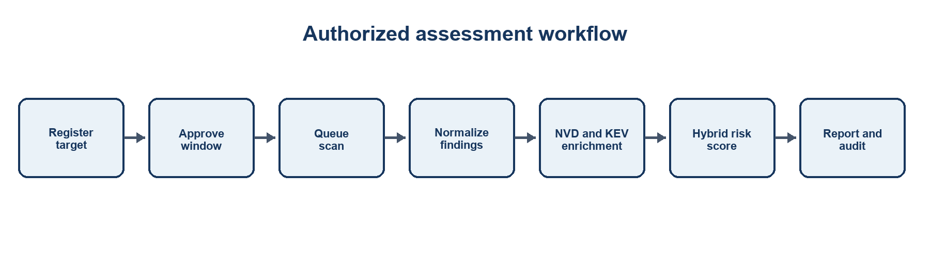
Fig. 3. Authorized assessment workflow

4.2.1 Algorithm 1 – Hybrid Risk Prioritization
Algorithm 1 combines deterministic security evidence with the trained classifier. The rule component retains an auditable relationship with CVSS, known exploitation and exposure. The model component uses CVSS, KEV membership, exposure, port, exploitability, age and CVSS vector categories. The final score is calculated as:

Final Risk = 0.40 x Rule Score + 0.60 x Machine Learning Score

Read the normalized finding, affected asset and enrichment record.
- Calculate the rule score from normalized CVSS severity, KEV membership and service exposure, then cap the result at 100.
- Transform numerical and categorical features using the trained preprocessing pipeline.
- Obtain Random Forest class probabilities and convert them into a weighted score from 0 to 100.
- Combine the component scores using the documented weights and classify the result as Low, Medium, High or Critical.
- Store the component scores, confidence, model version and a safe remediation recommendation.

4.2.2 Algorithm 2 – Authorized Adaptive Assessment
- Authenticate the requesting user and verify that the role permits assessment operations.
- Load the target and confirm that its authorization status is approved and the current time lies inside the stored window.
- For live mode, verify that live scanning is enabled, the selected adapter matches the assessment type and the executable is available.
- Create a queued scan record and write an audit event before execution.
- Execute the mock or controlled adapter in the worker, enforcing private-target policy, bounded arguments and timeouts.
- Normalize results, enrich CVEs, score findings and commit a completed status. On failure, store a bounded error and a failed status.
- Expose the resulting evidence through the dashboard and authenticated report endpoints.

4.3 Security Controls

Control | Implementation | Purpose
Authorization gate | Status and start/end time checked immediately before execution | Prevents scans outside approved scope
Private target policy | Public IP and domain targets rejected unless explicitly allowed | Reduces accidental external scanning
Role-based access | Admin, analyst and viewer dependencies on protected routes | Limits configuration and scan actions
Mock-first operation | Live scanning disabled in Docker configuration | Supports safe demonstration
Audit records | User, action, target, scan, client and details retained | Provides accountability
Bounded workers | Celery time limits and limited concurrency | Contains long-running tasks

5.EXPERMENTAL SETUP AND OUTPUT

5.1 Experimental Setup
The experiment used Docker Desktop on Windows to deploy the React frontend, FastAPI backend, PostgreSQL, Redis, Celery worker, MLflow, Prometheus and Grafana. The backend ran with live scanning disabled. A demonstration administrator and an authorized laboratory target were seeded. Trivy 0.66. 0 scanned the project filesystem for dependency vulnerabilities, secrets and Docker misconfigurations. Generated environments and dependency caches were excluded to prevent duplicate analysis and timeout. The resulting JSON report was submitted to the authenticated import endpoint for the authorized target.

5.2 Output of the Proposed System

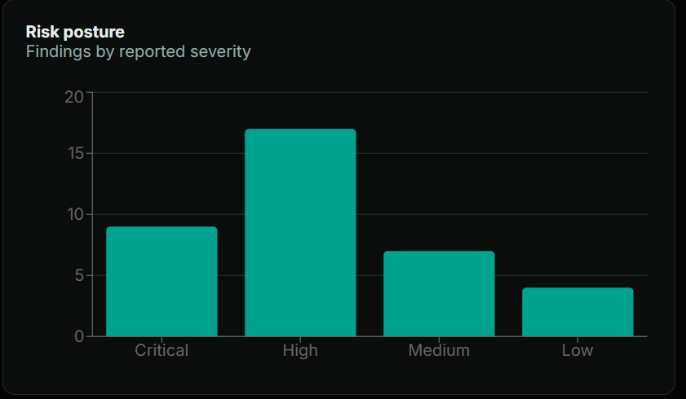
Fig. 4. Dependency findings detected by Trivy
The Trivy report contained 37 dependency vulnerability records and four Docker file misconfiguration records. The current importer converts dependency vulnerability records into the common finding model. Misconfiguration import is retained as future work; the source JSON remains available as evidence. Each imported dependency record receives an asset association, CVE enrichment when available, a hybrid score and a recommendation. The completed import created scan 2 and returned a completed status with 37 imported findings.

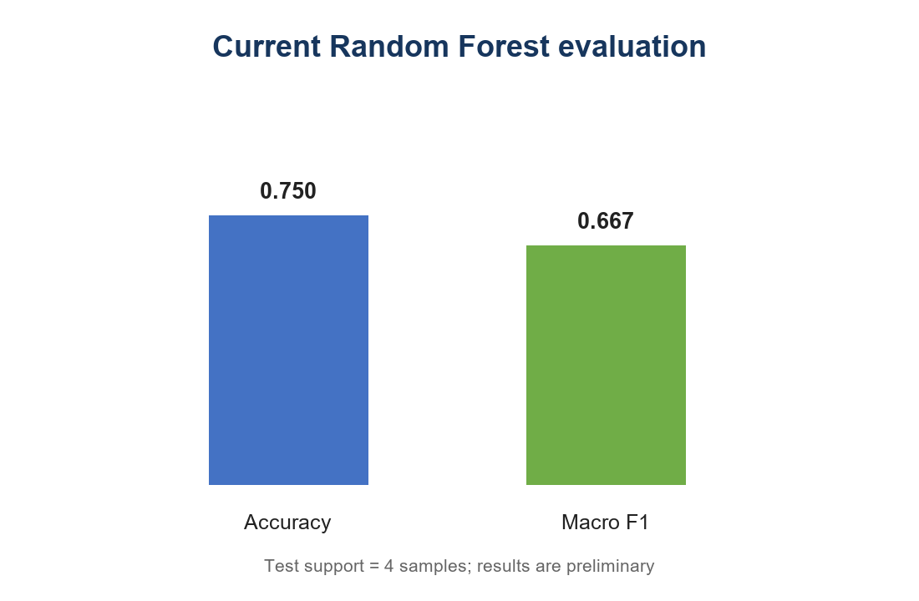
Fig. 5. Preliminary model evaluation
The bundled evaluation file records accuracy of 0.750 and macro F1 of 0.667. These metrics are calculated from only four test samples. They verify that the evaluation pipeline runs and produces per-class evidence, but they do not establish expected performance on an operational vulnerability population. A larger NVD and KEV-derived labelled dataset is required before comparing models or setting acceptance thresholds.

6. RESULT ANALYSIS

6.1 Comparison with existing approaches
Criterion | CVSS-only triage | Raw scanner output | Proposed system
Severity | Standard technical severity | Tool-specific severity | CVSS retained as one input
Active exploitation | Not represented by base score | Varies by tool | CISA KEV enrichment
Local exposure | Not included | Partial port or URL evidence | Asset and service exposure features
Machine learning | None | Usually none | Random Forest score and confidence
Explainability | Metric vector | Tool message | Rule components and SHAP factors
Authorization | Outside scoring model | Tool-dependent | Stored approval window and role checks
Auditability | No workflow history | Separate logs | Central scan and audit records
Reporting | Severity list | Tool-specific format | PDF, CSV and JSON

The proposed system’s main improvement is integration rather than a claim of higher predictive accuracy. CVSS-only triage provides a consistent technical baseline, and raw scanners provide detection evidence. The project adds authorization, normalization, threat enrichment, local exposure, model confidence and centralized evidence. This allows an analyst to see why two findings with similar severity receive different priorities. The current model dataset is too small for a statistically meaningful accuracy comparison, so the report does not claim superiority over EPSS or commercial platforms.

6.2 Operational Observations
- PostgreSQL and Redis health checks removed the observed startup race in which the API attempted a database connection before PostgreSQL was ready.
- Separating jobs through Celery prevented assessment processing from blocking the request process.
- Excluding generated caches reduced Trivy traversal time and produced a successful report while preserving source and dependency manifests.
- The Trivy importer required time zone normalization for NVD publication dates; the corrected implementation accepts both offset-aware and offset-naive source timestamps.
- Prometheus scraping confirmed that the metrics endpoint remained available throughout the import workflow.

6.3 Limitations
- The labelled model dataset and four-sample test split are insufficient for deployment-level validation.
- Trivy misconfiguration records are detected but are not yet imported into the common vulnerability table.
- Live scanner execution requires a controlled laboratory configuration and was not part of the reported Trivy experiment.
- NVD and KEV enrichment depends on network availability and upstream data quality; empty enrichment does not prove a vulnerability is safe.
- SHAP explains the trained model’s behaviour, not causality and not the truth of a scanner finding.
- The prototype uses development credentials and defaults that must be replaced before any shared deployment.

7.CONCLUSION AND FUTURE WORKS

7.1 Conclusion
The project produced a working safety-first prototype for authorized vulnerability assessment and risk prioritization. It connects target authorization, queued assessment execution, normalized findings, NVD and KEV enrichment, hybrid scoring, explanations, recommendations, reports and monitoring in one Docker deployment. The Trivy experiment demonstrated an end-to-end path from filesystem scanning to 37 stored and scored dependency findings. The implementation therefore satisfies the project objective of building an auditable assessment assistant. Its present evidence supports functional feasibility, not a claim of production readiness or model superiority.

7.2 Proposed Outcome
The immediate outcome is a functional software product prototype suitable for an academic demonstration. After collecting a substantially larger labelled dataset and comparing Random Forest with logistic regression and gradient boosting, the prioritization and explainability study can be developed into a conference paper. A patent claim is not proposed at this stage because the present architecture combines established open-source components and scoring concepts; novelty would require a separate prior-art review and a clearly differentiated method.

7.3 Future Work
- Build a larger time-split dataset from NVD, CISA KEV and observed exploitation labels, then report confidence intervals and calibration.
- Compare Random Forest with logistic regression and gradient boosting through MLflow using fixed datasets and reproducible runs.
- Import Trivy secret and misconfiguration records with dedicated schemas and remediation types.
- Complete Alembic-managed schema evolution and replace development credentials with managed secrets and refresh-token controls.
- Add deduplication across repeated scans and a verified DefectDojo API upload option.
- Evaluate Nmap, Nuclei and passive ZAP adapters only in an isolated laboratory with defined rate limits and scope fixtures.
- Add probability calibration, drift monitoring and analyst feedback without allowing the model to authorize actions.

8. REFERENCES
[1] N. Becker, D. Reti, E. V. Ntagiou, M. Wallum, and H. D. Schotten, “Evaluation of Reinforcement Learning for Autonomous Penetration Testing Using A3C, Q-Learning and DQN,” arXiv preprint arXiv:2407.15656, 2024.
[2] R. Fernandes, N. Lopes, J. Gonçalves, and J. Cosgrove, “Autonomous Pentesting Using Artificial Intelligence: From the Cybersecurity Point of View,” Internet of Things, vol. 37, art. 101932, 2026, doi: 10.1016/j.iot.2026.101932.
[3] A. Happe and J. Cito, “On the Surprising Efficacy of LLMs for Penetration Testing,” arXiv preprint arXiv:2507.00829, 2025.
[4] J. Henke, “AutoPentest: Enhancing Vulnerability Management with Autonomous LLM Agents,” arXiv preprint arXiv:2505.10321, 2025.
[5] J. A. Curtis and N. U. Eisty, “The Role of AI in Modern Penetration Testing,” arXiv preprint arXiv:2512.12326, 2025.
[6] R. Zhan, J. Zhu, Y. Xu, C. Chen, R. Hu, and L. Wang, “L-ARLPT: An LLM-Augmented Reinforcement Learning Framework for Autonomous Penetration Testing,” Applied Sciences, vol. 16, no. 16, art. 7887, 2026, doi: 10.3390/app16167887.
[7] J. Liu, Y. Zhang, S. Zhou, J. Yang, Y. Lu, and X. Zhong, “Autonomous Penetration Testing Using Reinforcement Learning: A Review and Perspectives,” Expert Systems with Applications, vol. 300, art. 130219, 2026, doi: 10.1016/j.eswa.2025.130219.
[8] L. Wang, X. Shi, Z. Li, Y. Jiang, S. Tan, Y. Jiang, J. Cheng, W. Chen, X. Shen, Z. Li, and Y. Chen, “Automated Penetration Testing with LLM Agents and Classical Planning,” arXiv preprint arXiv:2512.11143, 2025. [Online]. Available: https://arxiv.org/abs/2512.11143.
[9] S. Zhou, J. Liu, Y. Lu, J. Yang, Y. Zhang, and J. Chen, “Mind the Gap: Towards Generalizable Autonomous Penetration Testing via Domain Randomization and Meta-Reinforcement Learning,” Frontiers of Information Technology & Electronic Engineering, vol. 26, no. 12, pp. 2511–2528, 2025, doi: 10.1631/FITEE.2500100.
[10] N. Das, “An Explainable Machine-Learning Framework for Prioritizing Cybersecurity Vulnerabilities in the Post-Mythos Era,” Journal of Computer Science and Technology Studies, vol. 8, no. 8, pp. 213–221, 2026, doi: 10.32996/jcsts.2026.8.8.14.
[11] FIRST, “Common Vulnerability Scoring System Version 4.0 Specification,” 2023. [Online]. Available: https://www.first.org/cvss/.
[12] Cybersecurity and Infrastructure Security Agency, “Known Exploited Vulnerabilities Catalog.” [Online]. Available: https://www.cisa.gov/known-exploited-vulnerabilities-catalog.
[13] National Institute of Standards and Technology, “National Vulnerability Database.” [Online]. Available: https://nvd.nist.gov/.

